WEEK 8

**Logistic Regression**

Assume we have a dataset that is linearly separable and has the output that is discrete in two classes (0, 1).  if we try to use linear regression to solve a binary class classification problem, the regression like looks as follows.

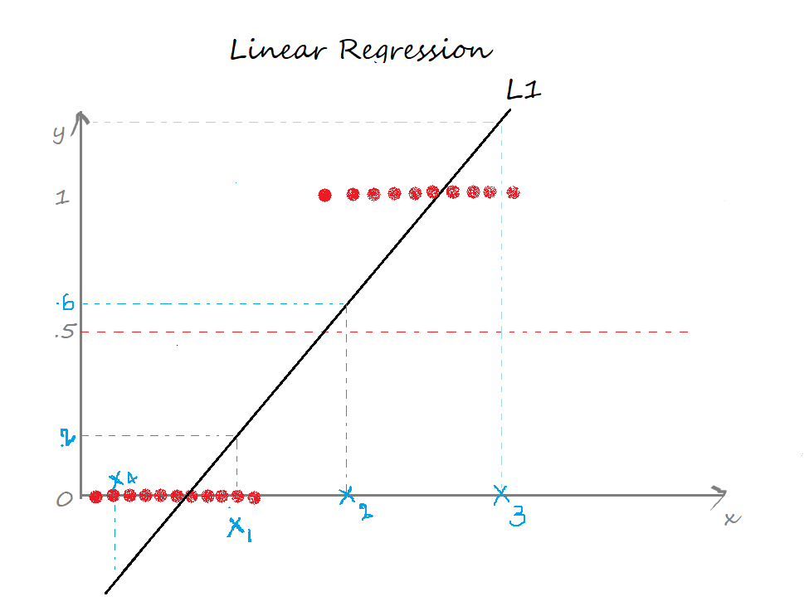

The two limitations of using a linear regression model for classification problems are:

* the predicted value may exceed the range (0,1)
* error rate increases if the data has outliers

There definitely is a need for Logistic regression here.

Logistic Regression is a Machine Learning algorithm which is used for the classification problems, it is a predictive analysis algorithm and based on the concept of probability.

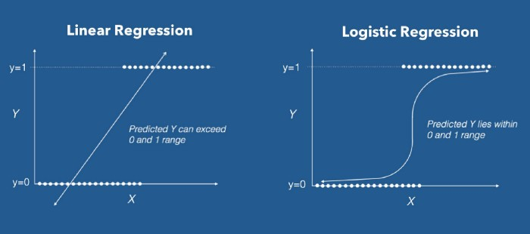

Logistic Regression uses a more complex cost function, this cost function can be defined as the ‘**Sigmoid function**’ or also known as the ‘logistic function’ instead of a linear function. The hypothesis of logistic regression tends it to limit the cost function between 0 and 1. In order to map predicted values to probabilities, we use the Sigmoid function. The function maps any real value into another value between 0 and 1. In machine learning, we use sigmoid to map predictions to probabilities.

